Customer Shopping Behaviour Analysis

- Project Overview
The project analyses customer behaviour using transactional data from 3,900 purchases across various product categories. The goal is to uncover insights into meaningful patterns, customer segments, product preferences, and subscription behaviour to guide strategic business decisions.

- DataSet Summary
--Rows:3900
--Columns:18
Key Features:
-Customer demographic ( Age, Gender, Location, Subscription Status)
-Purchase details (Item purchased, Category, Purchase Amount, Season, Size, Color)
-Shopping behaviour (Discount applied, Promo Code Used, Previous Purchases , Frequency of Purchases, Review rating, Shipping Type)
-Missing values: 37 values in Review Rating Column

3.EDA using Python
Step 1: Data Loading
Load and import the dataset using pandas.
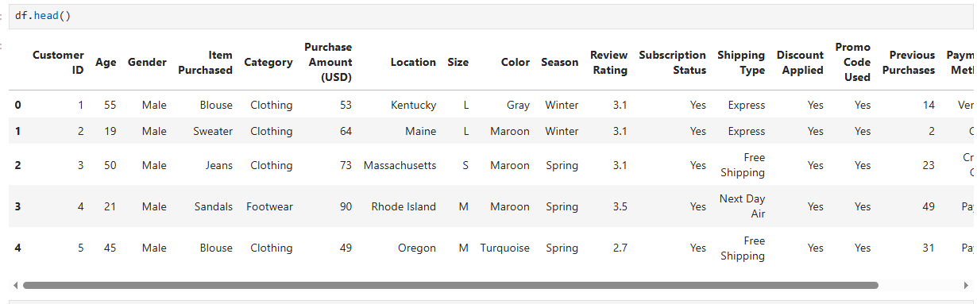

Step 2 : Initial Data Understanding:
To understand the structure and quality of the dataset, the following functions were used:
- df.head() → To view first few rows
- df.info() → To check data types and non-null counts
- df.describe(include="all") → To get statistical summary
- df.isnull().sum() → To detect missing values

Step 3: Handling Missing Values (Data Cleaning)
Missing values were found in the Review Rating column.
Instead of removing rows, missing values were filled using median imputation based on category.

Step 4: Case Snaking (Column Name Standardization)
Column names were standardized by:
- Converting all column names to lowercase
- Replacing spaces with underscores

Step 5: Feature Engineering
New meaningful features were created to improve analysis.
- A new column age group was created using quartile-based segmentation. For this purpose we use “pd.qcut( )” function.
- A new numerical column purchase_frequency_days was created by mapping textual frequency into number of days.
Example:
- Weekly → 7
- Monthly → 30
- Quarterly → 90

Step 6: Removing Duplicate Information (Data Reduction)
It was found that both columns contained identical values.
Therefore, one redundant column (promo_code_used) was dropped.

3.Data Analysis using SQL
We peformed structred analysis in MYSQL to answer key business questions:
Revenue by Gender: What is the total revenue generated by male vs female customer?
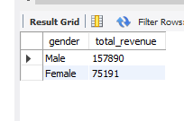

High-Spending Discount Users: Which customers used a discount but still spent more than the average purchase amount?
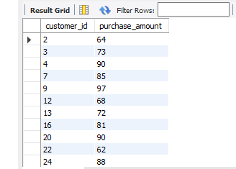

Top 5 Products by Rating: Which are the top 5 products with the highest average review rating?
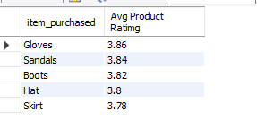
Shipping: Compare the average Purchase Amounts between Standard and Express Shipping.
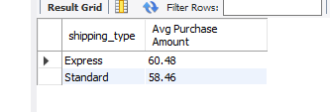

Subscriber vs Non-subscriber: Do subscribed customers spend more? Compare average spend and total revenue between subscribers and non-subscribers?
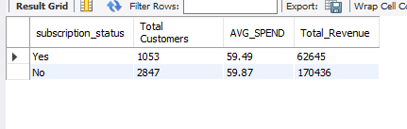
Top 5 products with discount: Which 5 products have the highest percentage of purchase with discount applied?
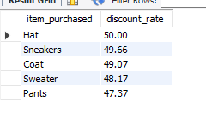
New,Returning,Loyal: Segment customers into New, Returning, and Loyal based on their total number of previous purchase and show the count of each segment?
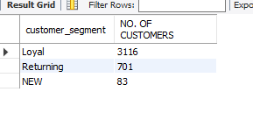
Top 3 most purchased products in Each Category:
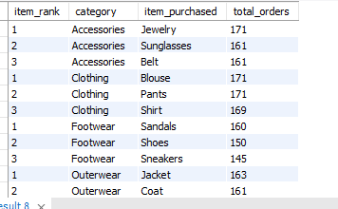

Repeat buyers:Are customers who are repeat buyers (more than 5 previous purchases) also likely to subscribe?
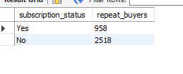
Age Group: What is the revenue contribution of each group?
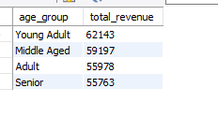

5.Dashboard in PowerBi
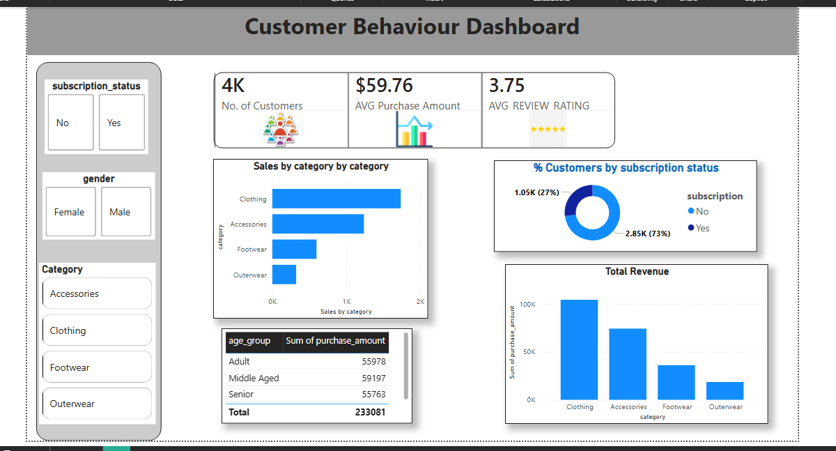

6.Business Recommendation
- Boost Subscription: Promote exclusive benefits for subscribers.
- Customer Loyalty Programs: Reward repeat buyers to move them into “Loyal” segment.
- Review Discount Policy: Balance sales boosts with margin control.
- Product Positing: Highlight top-rated and best-selling products in campaigns.
- Targeted Marketing: Focus efforts on high-revenue age groups and express-shipping users.

